Project Proposal

Classification model for discovering the type of crop to plant Using Convolutional Neural Network

Uma Mahesh Addanki

Graduate student

School of computer science

California state university, San Bernardino

**Committee Members**

**Advisor : Dr Bhilal Khan**

**Abstract**

Choosing the right type of crop to plant on a farm is very important. This is because different areas have different soil properties, which in turn keep changing every season due to the different inputs farmers keep adding to their farms to increase productivity. Thus, farmers need help deciding which crop to plant based on the changing natural factors and soil properties. This research proposal aims to develop a classification model that seeks to discover the type of crop a farmer can plant based on the existing natural factors, including the soil properties. The model development will use the natural crop datasets with the required features to achieve accuracy. The data analysis process and development of the model will be achieved using Convolutional Neural Networks to classify the thousand's different types of crops.

**Objective and Scope of the Project**

**Objective**

This study aims to design a classification model that serves as a decision-making tool for farmers who are in the Netherlands farms for being in a position to understand which type of crop best suits their farm at the time of cultivation.

**Scope**

The primary purpose of this project is to develop a classification model, a small initiative enhancing agriculture, and help farmers make smart decisions to consider the demographics of their field and the factors affecting their crop for a super great yield.

**Proposed System**

The main focus of this project is to develop a classification model that will focus on solving natural farm problems. Unlike the current systems, farmers can determine which crop best suits their soil.

In summary, my project was to be helpful for farmers in sorting out their crop yield farm issues with easily than they have been used to. Through the proposed classification model, farmers increase their crop yield production since they can control the natural factors which are the primary determinant when growing crops.

**Project Design**

# Figure 1: Activity diagram

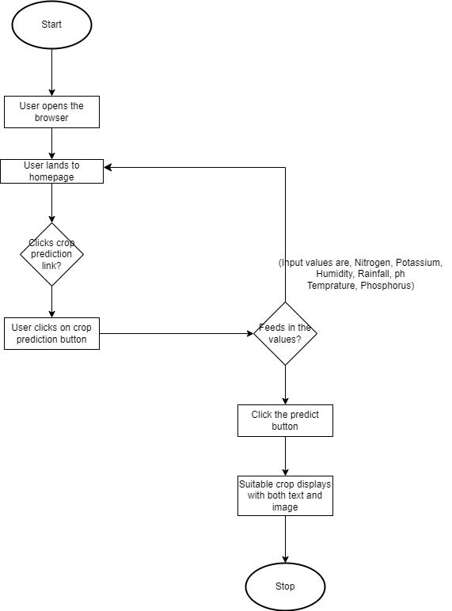

# Figure 2: Data flow diagram

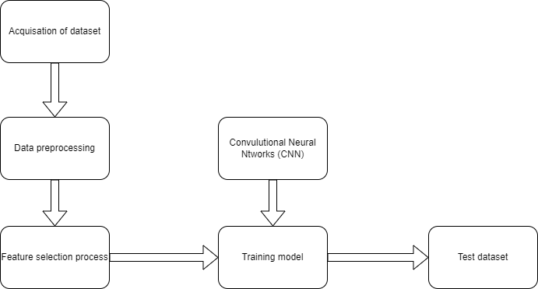

# Figure 3: Use case diagram

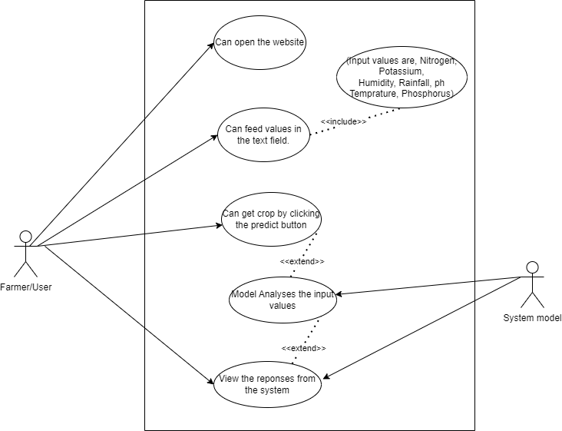

# Figure 4: Sequence diagram

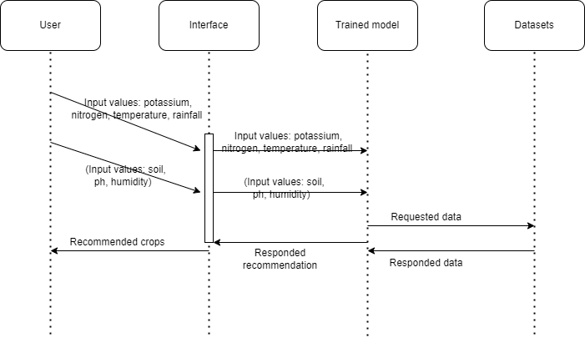

## **Project timeline**

|  |  |  |  |  |  |  |  |  |  |  |  |  |  |
| --- | --- | --- | --- | --- | --- | --- | --- | --- | --- | --- | --- | --- | --- |
| Weeks | 1 | 2 | 3 | 4 | 5 | 6 | 7 | 8 | 9 | 10 | 12 | 13 | 14 |
| Feasibility study |  |  |  |  |  |  |  |  |  |  |  |  |  |
| Requirement analysis & specification |  |  |  |  |  |  |  |  |  |  |  |  |  |
| System design |  |  |  |  |  |  |  |  |  |  |  |  |  |
| Coding and unit testing |  |  |  |  |  |  |  |  |  |  |  |  |  |
| Integration and system testing |  |  |  |  |  |  |  |  |  |  |  |  |  |
| Maintenance |  |  |  |  |  |  |  |  |  |  |  |  |  |

**Project Implementation**

**Software Requirements;**

1. Google Colab – provides a platform for executing python code through the browser.
2. Google Chrome – This browser was handy for accessing online research whenever a consultation was needed. As well used in testing the functional requirements of the online web chatting application.
3. Operating system - windows 10 and above is needed in the development of this online web chatting system.
4. Visual Studio – this is the official IDE for developing different online web applications. Has all features required in the development and testing of the developed application before release to the market.

**Hardware Requirements;**

1. Laptop – This is the main device used to code the whole application and store the application modules for the proper execution of the project during and after development.
2. Core i5: 2.4 GHz processor and above
3. Hard drive: 40 GB
4. Monitor: 15 VGA color monitor
5. Ram: 4GB and above

**Language Requirements;**

1. Python - is a scripting programming language to be used in developing the proposed application.
2. JavaScript - client-side language for adding interactivity to web pages.

**Library Requirements;**

1. TensorFlow – machine learning library used in training and inference of deep neural networks.
2. Flask - backend framework used in developing web servers to serve the client side of an application.
3. Pandas - is a python library open-source tool used for data analysis and manipulation.
4. NumPy - is a python library open-source tool that adds support for large multidimensional arrays and matrices along with an extensive collection of high-level math functions that operate on these arrays.

**References**

Alshamrani, A., & Bahattab, A. (2017). A comparison between three SDLC models waterfalls model, spiral model, and Incremental/Iterative model. *International Journal of Computer Science Issues*.

Beeharry, Y., Fowdur, T. P., & Sunglee, J. A. (2019). A cloud-based real-time weather forecasting application. *In 2019 14th international conference on advanced technologies, systems, and services in telecommunications (TELSIKS)*, 294-297.

Hakkim, V. A., Joseph, E. A., Gokul, A. A., & Mufeedha, K. (2020). Precision farming: the future of Indian agriculture. *Journal of Applied Biology and Biotechnology*, 0-7.

Holmstrom, M., Liu, D., & Vo, C. (2018). Machine learning applied to weather forecasting. *Meteorol. Appl 1-5.*, 1-5.

Irungu, K. R., Mbugua, D., & Muia, J. (2019). Information and Communication Technologies (ICTs) attract youth into profitable agriculture in Kenya. *East African Agricultural and Forestry Journal*, 24-33.

Jr, H., O., L., Hammond, K. R., Lusk, C. M., & Mross, E. F. (2019). The application of signal detection theory to weather forecasting behavior. *Monthly Weather Review*, 863-883.

Liu, S., & Wei, J. (2018). The Satelite on the Research of the Software Life Cycle: V+ Iterative Waterfall. . *In 2018 2nd IEEE Advanced Information Management, Communicates, Electronic and Automation Control Conference*, 1716-1720.

Ruedeeniraman, N., Ikeda, M., & Barolli, L. (2020). *Performance evaluation of VegeCare tool for potato disease classification.* In International Conference on Network-Based Information SystemsSpringer, Cham.

Shylesh, S. (2017). A study of software development life cycle process models. . *In National Conference on Reinventing Opportunities in Management, IT, and Social Sciences*, 534-541.